Çankaya University
Department of Computer Engineering
CENG 218 Data Structures 2025-2026 Spring Midterm 2 Exam

Instructor: Dr. Abdul Kadir GORUR

Time Allowed: 100 minutes Date: 04/05/2026 10:20
Signature:
Name and Surname : ………………………………………
Student Number : ………………………………………

This is a closed book, closed notes exam. The use of any electronic devices—including but not limited to smartphones, smartwatches, tablets, calculators, or any other electronic equipment—is strictly prohibited. Any attempt to use such devices during the exam may lead to disciplinary action in accordance with university policies. Important: Do not ask the invigilators any questions related to the content of the exam.
template<typename T>
class Stack {
private:
//private members
//we do not need these details
public:
Stack();
void push(const T& value);
T pop();
T top() const;
bool isEmpty() const;
};
//usage of the verion is as follows
//If you need stack for char type
Stack<char> s;
//If you need stack of Node* (node pointer types)
Stack<Node*>
template<typename T>
class Queue {
private:
//private members
//we do not need these details
public:
Queue();
void enqueue(const T& value);
T dequeue();
bool isEmpty() const;
};
//usage of the verion is as follows
//If you need stack for char type
Queue <char> s;
//If you need stack of Node* (node pointer types)
Queue <Node*>

class LinkedList {
private:
Node* head;
public:
LinkedList():head(nullptr){}

};
class Node {
private:
int data;
Node* next;
public:
Node (int d=0):data(d),next(nullptr){}
};
class BTNode {
private:
int data;
BTNode *left,*right;
public:
Node (int d=0):data(d),left(nullptr),right(nullptr){}
};

class BinaryTree {
private:
BTNode* root;
public:
BinaryTree():root(nullptr){}

};
class BST {
private:
BTNode* root;
public:
BST ():root(nullptr){}

};

Q1(25p) | Q2(20p) | Q3(20p) | Q4(25p) | Q5(10p) | Total

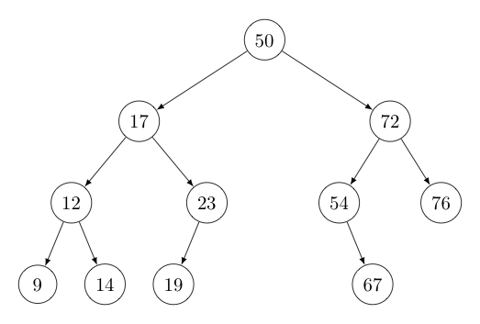
Q1-a)(15p) Consider above binary tree and write the following traversal outputs
Inorder Traversal:
Preorder Traversa:
Postorder Traversal:

Q1 b)(10p) You are given the following sequence of 10 integer values: 45, 12, 78, 34, 23, 56, 89, 10, 67, 25
Insert these values one by one in the given order into an initially empty Binary Search Tree (BST). After each insertion, redraw the entire Binary Search Tree. Answers that include only the final tree will NOT be graded.

Q2)(20p) Midpoint Symmetry of Queue: Write a function that determines if a single queue is "mirror-symmetric." A queue is mirror-symmetric if the top half of its elements is a mirror image of the bottom half.
Queue q (front → rear): 1, 2, 3, 3, 2, 1 Returns true
Queue q (front → rear): 1, 2, 3, 1, 2, 3 Returns: false
bool isMirrorSymmetric(Queue<int> &q) { // Your implementation here }
Q3) (20p)You are given a singly linked list that stores integers. Your goal is to write a recursive member function deleteGreater(int threshold) for a LinkedList class. This function should traverse the entire list and remove every node whose value is strictly greater than the provided threshold. Ensure that you function handles all cases.

Q4) For a Binary Tree class
a)(15p)Write a non recursive function called countNodes that returns the number of nodes that have only one child

b)(10p)Write a recursive function called countNodes that returns the number of nodes that have only one child.

Q5) (10p)
void f(char *str) {
if (*str == '\0') return;
if (*str == 'a')
*str = '*';
f(str + 1);
str[0]=’6’;
}
“What will be the output when the function is applied to char s[] = "madam"? Draw the complete recursive execution sequence and show how the output is generated.

